Strike Weight Procedure
David Love, San Francisco Chapter

I remain committed to creating smooth strike weight curves for a variety of reasons. A smooth strike weight curve is necessary in order to have a smooth inertia curve through the action as well as a smooth curve of front weights and the ability to precalculate lead placements. This avoids the time consuming hassle of doing a weigh-off of the action with upweights and downweights and converting that to front weight specs or changes. On the action described below I found that some SWs required a change of one full gram to put them on the curve. That is quite significant in terms of both static and dynamic force. It is not unusual (and wasn’t in this case) to alter the strike weights by half a gram or more. But creating the curve in a way that is efficient can be challenging.

In the past, after assembling the hammers, I had generally removed each hammer assembly, cut off the excess shank and then measured the strike weight on a scale and replaced each assembly. Once I had a chart of the existing strike weights I then put them on a spread sheet and calculated a trendline for the existing curve (rather than matching a preexisting curve). I then use the trendline to determine my final strike weights and calculate the change required for each assembly. The sheet looks something like this:
 | U | D | SW Measured | SW Calc'd from Trendline | Final SW | Difference
1 |  |  | 11.3 | 11.7 | 11.9 | 0.6
2 |  |  | 11.2 | 11.6 | 11.8 | 0.6
3 |  |  | 11.4 | 11.5 | 11.7 | 0.3
4 |  |  | 11.3 | 11.5 | 11.7 | 0.4
5 |  |  | 11.4 | 11.4 | 11.6 | 0.2
6 |  |  | 11.2 | 11.3 | 11.5 | 0.3
7 |  |  | 11.2 | 11.3 | 11.5 | 0.3
8 |  |  | 11.1 | 11.2 | 11.4 | 0.3
9 |  |  | 11.0 | 11.2 | 11.4 | 0.4
10 |  |  | 11.1 | 11.1 | 11.3 | 0.2
11 |  |  | 11.4 | 11.0 | 11.2 | -0.2
12 |  |  | 10.8 | 11.0 | 11.2 | 0.4
13 |  |  | 11.1 | 10.9 | 11.1 | 0.0
14 |  |  | 11.1 | 10.8 | 11.0 | -0.1

Graphed, the entire set appears like this:

In this case the squiggly blue line is the actual measured strike weight curve (you can see you much it varies). The orange line is the calculated curve using the trendline (formula pictured on the chart). The final purple line is my final curve derived by adding .2 grams to the existing trendline. I’ve done this for two reasons. One is that I don’t like to have to whittle down the hammers further if I can avoid it, and two, the action ratio accommodated a bit more weight to hit my inertia targets.
The trendline is easily programmed into an excel spreadsheet. It looks something like this in the first cell (this would be for note #1)
=-0.0001*A11^2-0.0616*A11+11.722
Cell A11 (column A row 11) has in it the note number, in this case “1”. Cell A12 would have the number 2, etc. I posted something on this awhile ago. If you program the first cell and then drag it all the way down each subsequent cell will automatically fill with A12, A13, A14 etc.
So, previously, the next step for me was then to remove all the assemblies (yet again) put them back on the scale and add the appropriate amount of lead solder to the molding. But I didn’t care for removing the assemblies a second time so eventually found that I could do it while assembled. Since I have the weight difference required I just cut the piece of solder and place it on the scale. As pictured below.
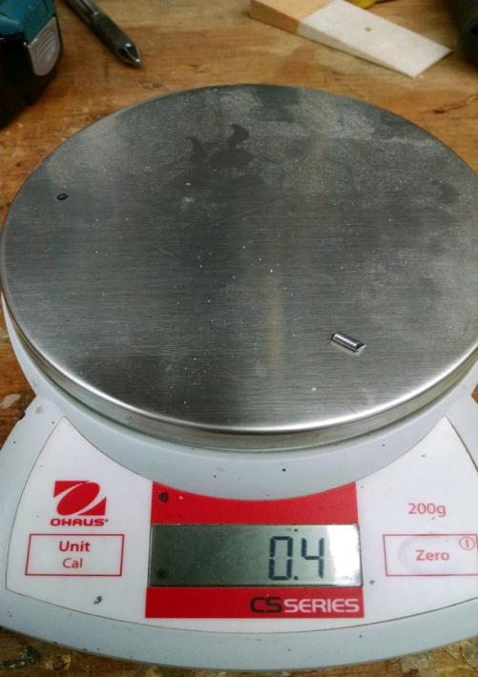
Drilling the hole in the molding requires a deft touch so as not to go through the molding all the way. I find that about .5 grams worth of solder is about all that the molding will take in terms of length. If I need to add more than that I do it in two pieces.

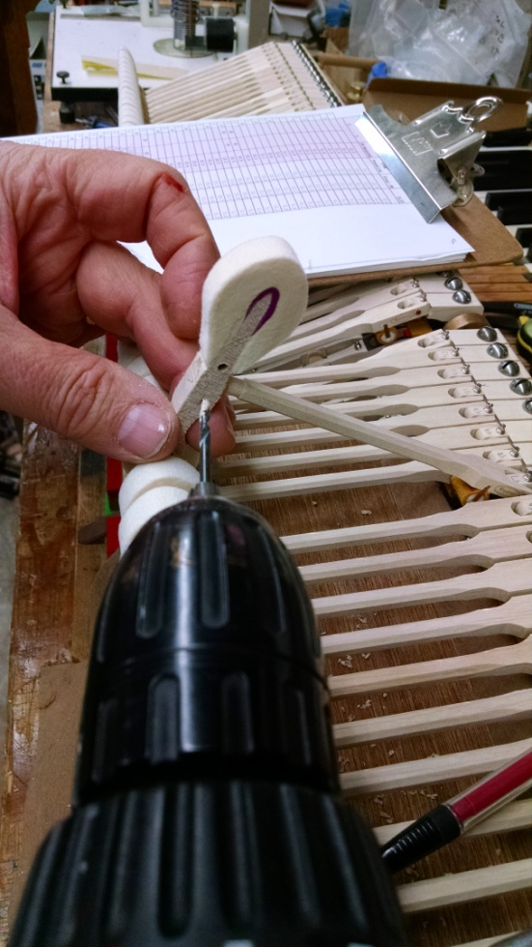
Using a pair of parallel pliers the lead can be squeezed into the hole and, if it extends out a bit, flattened against the molding. Sometimes this procedure is enough to create an effective swedging but sometimes not in which case I used a repining tool (a pair of center pin pliers would work as well) to swedge the lead into the molding.
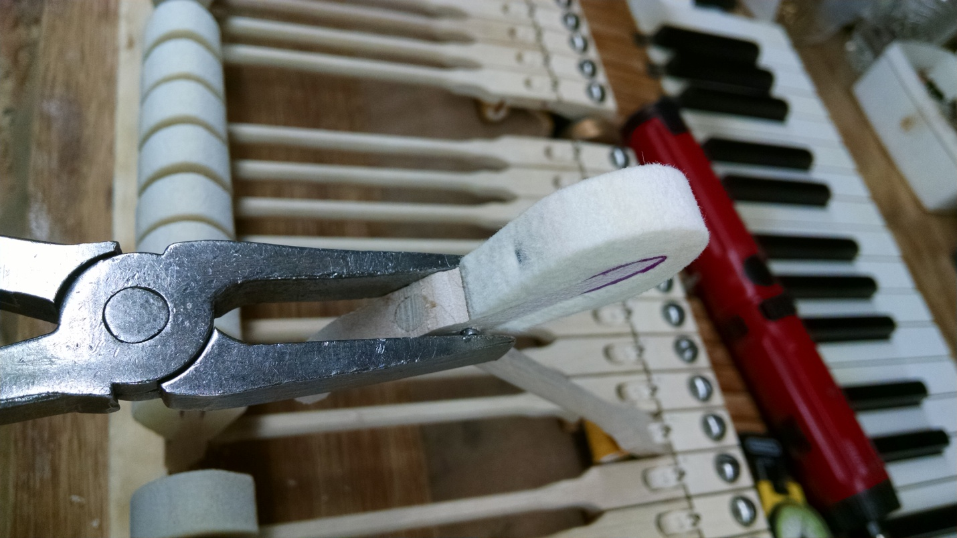

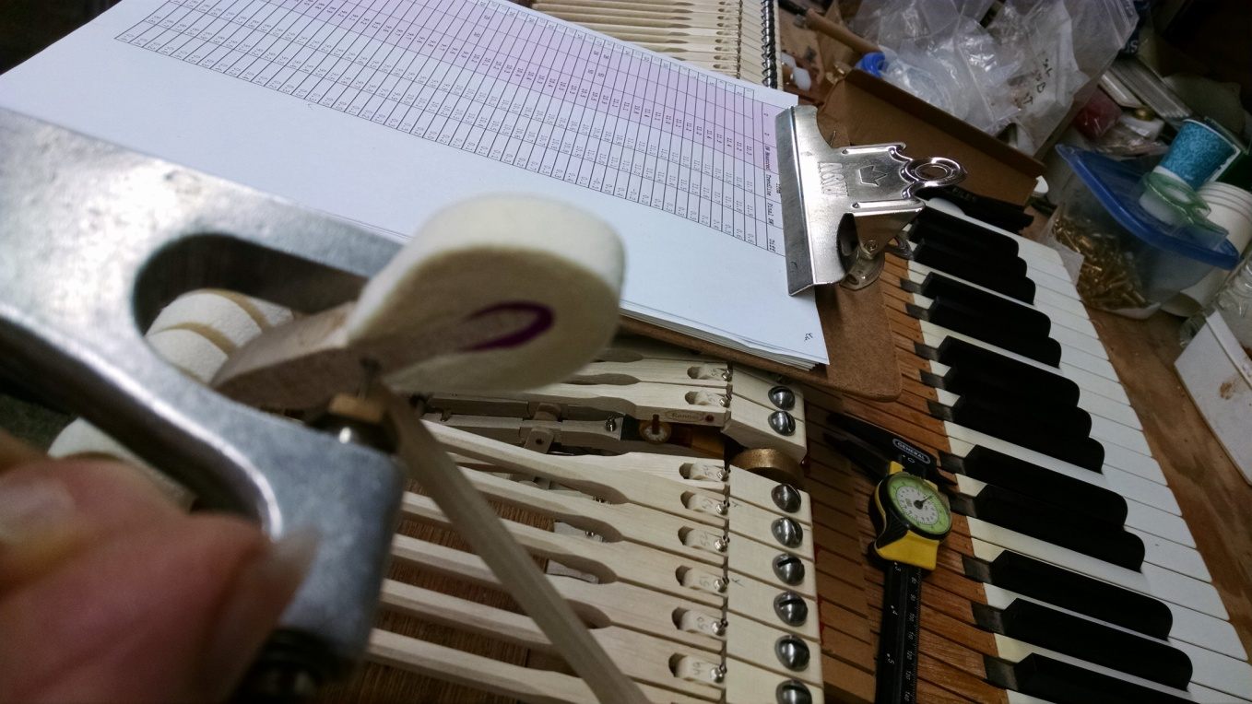

Working this way it goes very quickly. In this case I had already aligned this set of hammers to the strings so I did not have to redo that. Some care must be taken that you don’t stress the centers and if you happen to drill all the way through the molding you will have to slide a thin piece of metal on the backside to swedge against. Otherwise there is no real downside. This method allows you to run some additional tests on the action once it’s assembled and regulated in order to determine what your final SW curve will look like in the event you want to do some experimenting first.
It would be easy enough to create a modified fitting for the center pin tool that would replace the center pin sized removing pin with a thin rod more appropriately sized for swedging the lead, but for now this works just fine.

David Love
11/24/15

