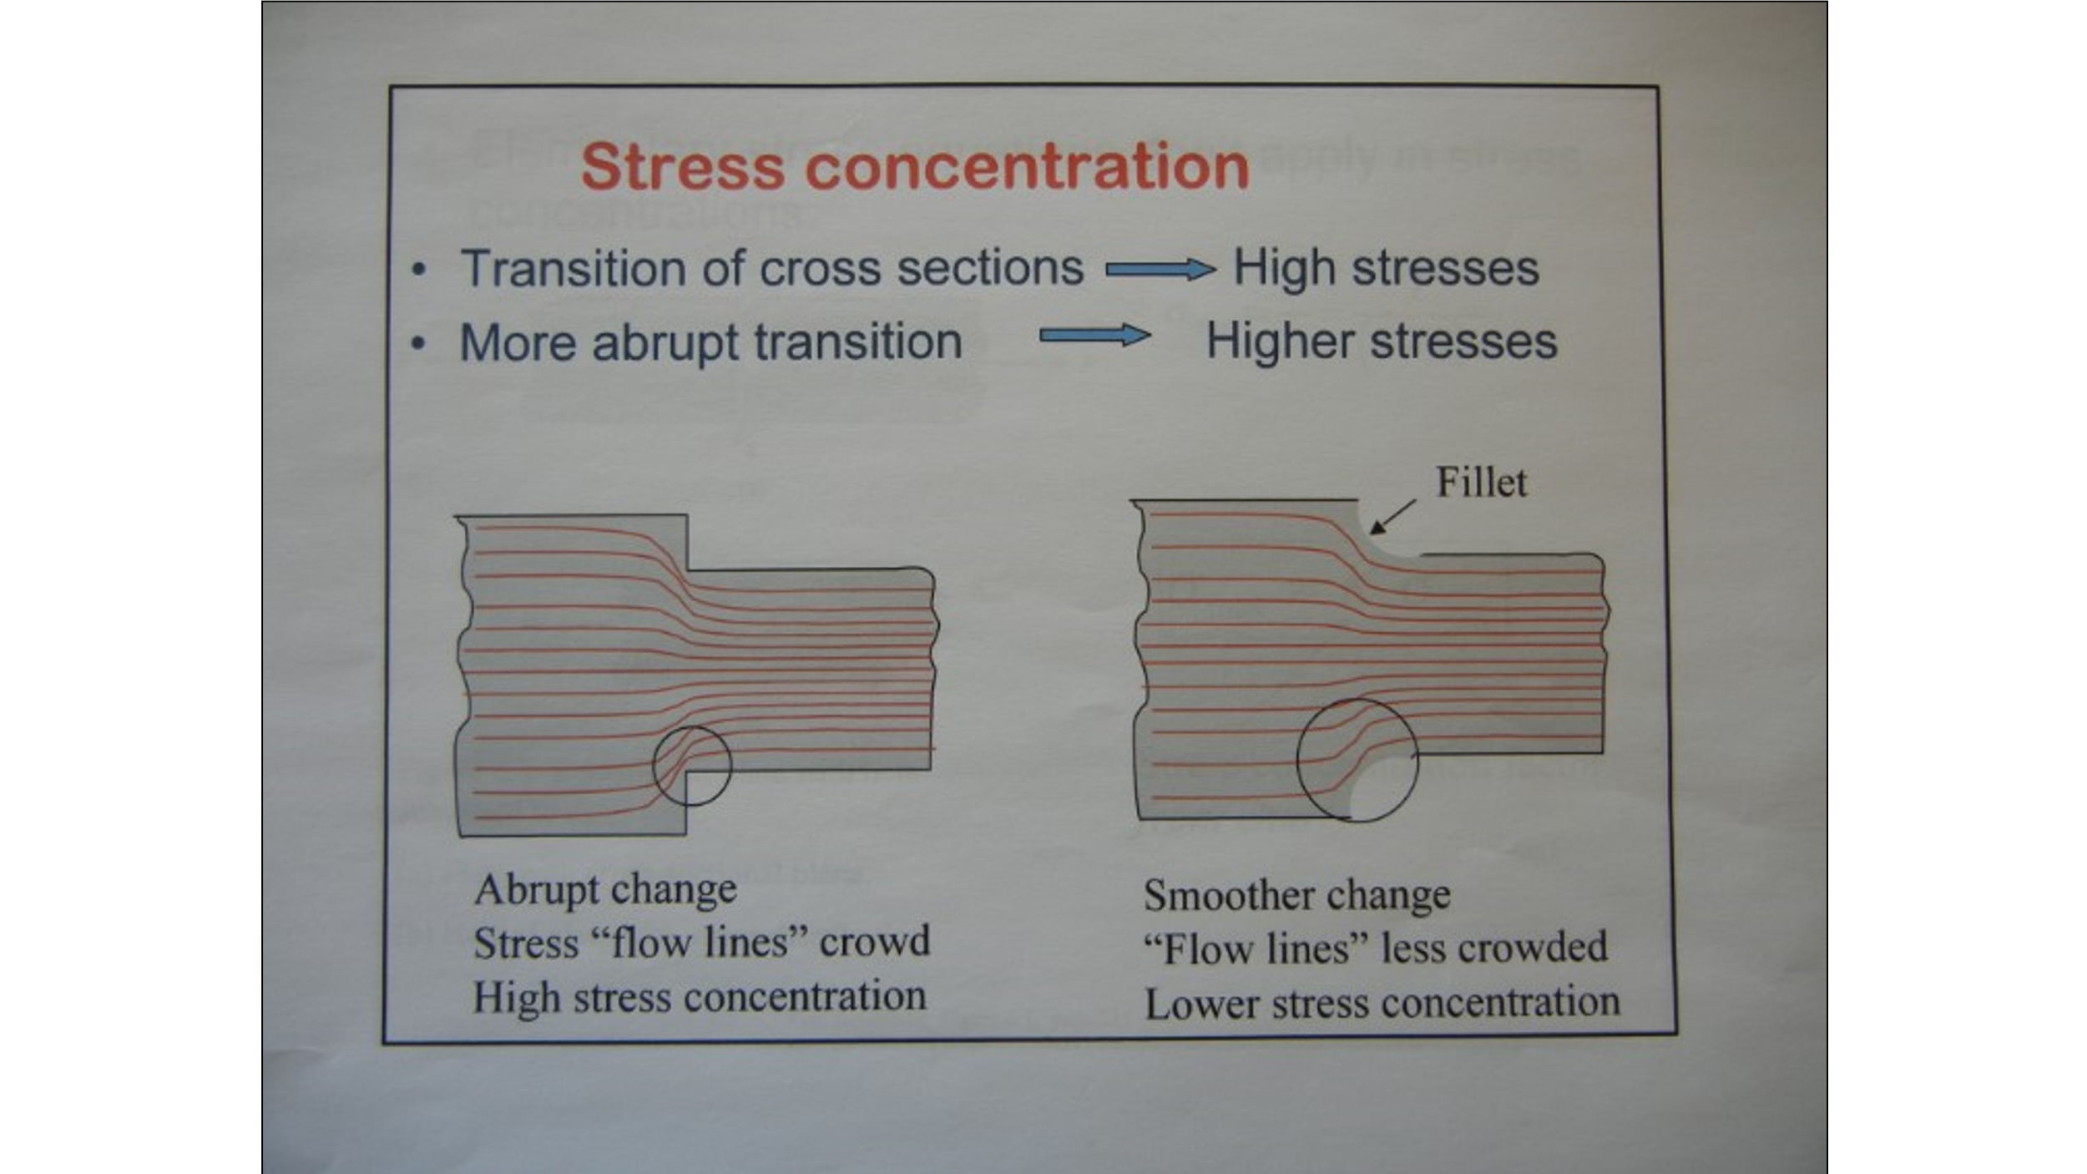

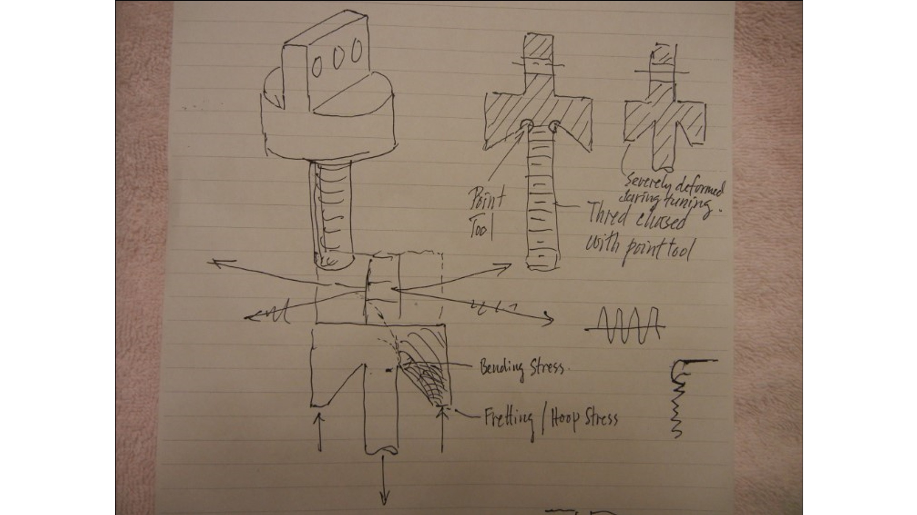
These are notes from Professor Robert Wei, author of the book Fracture Mechanics.
He was doing a study on stress fractures when an agraffe broke on his wife’s model B, #474747 He took the broken agraffe to work and put in the electron microscope
