FOR SALE:
Soundboard press, custom built go-bar system. Bed frame and top deck frame are constructed with 2”x6” box steel beams. Bed is 5’x7’ and is machined out to a true sixty-foot radius.
The bed may be removed to expose a flatbed which is used to glue the bridges onto the board and can be used for gluing up veneer.
Included are go-bars and radiused support blocks for gluing on the bridges. Size of bed is large enough to do a board for a nine-foot grand. $2,500.
Included:
Rib crowning jig.
Twenty-eight bar clamps.

Must pick up before September 10.
Located in Allentown, PA
Contact John Zeiner, Sr. jzeiner584@aol.com
610-390-1605 cell

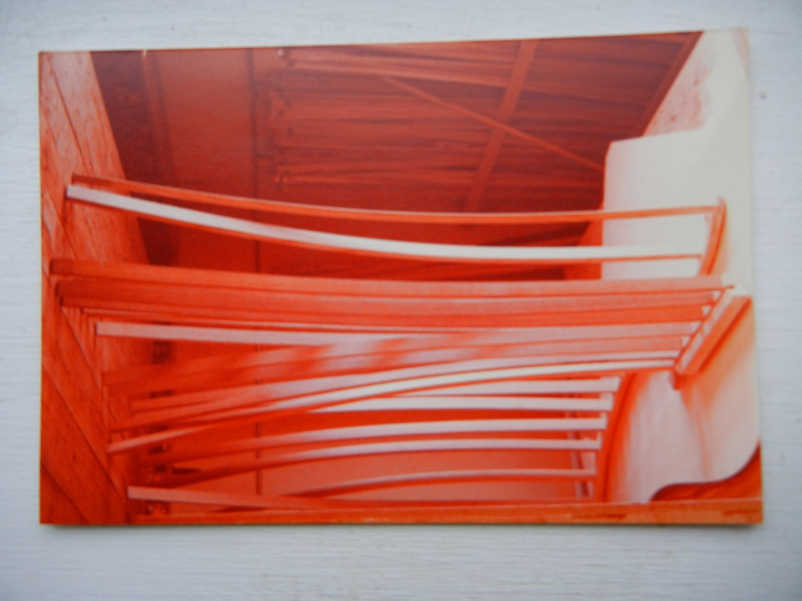

Gluing the bridges on.
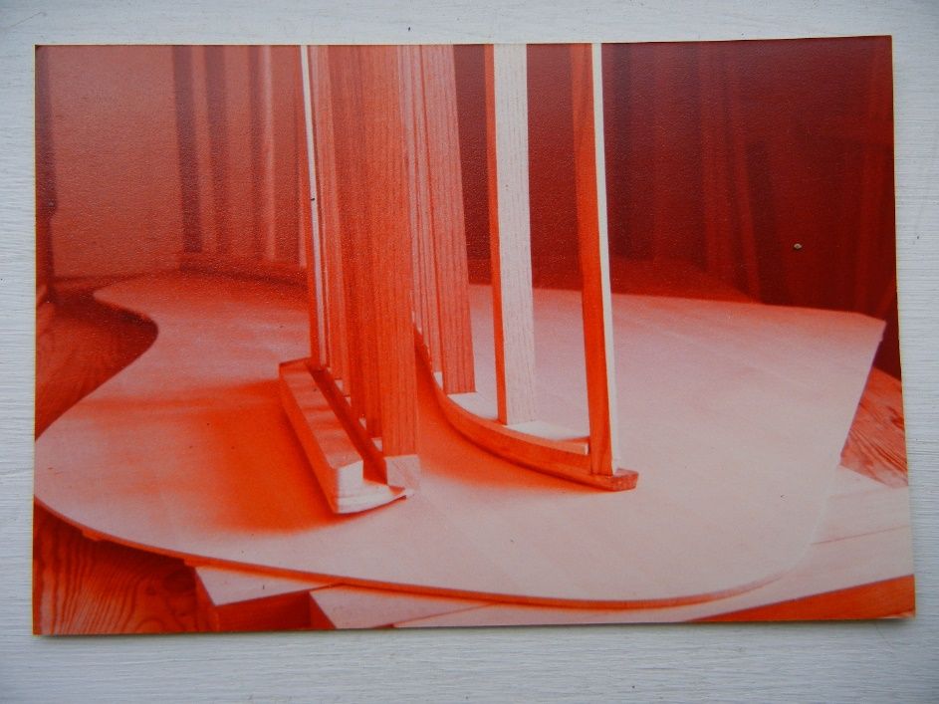
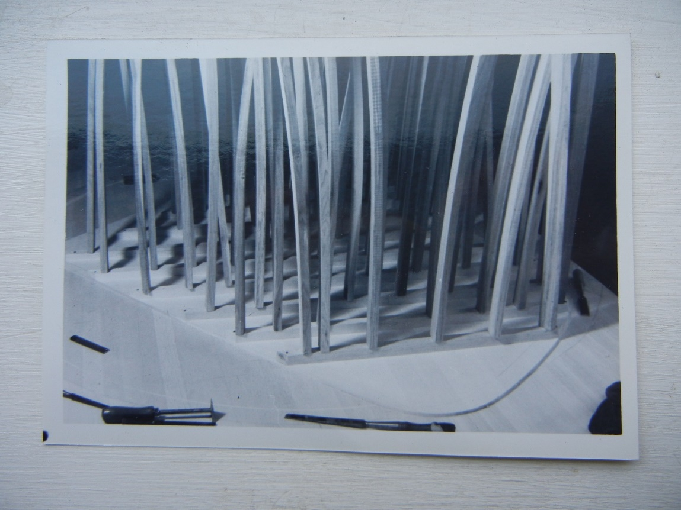

Gluing on the ribs.
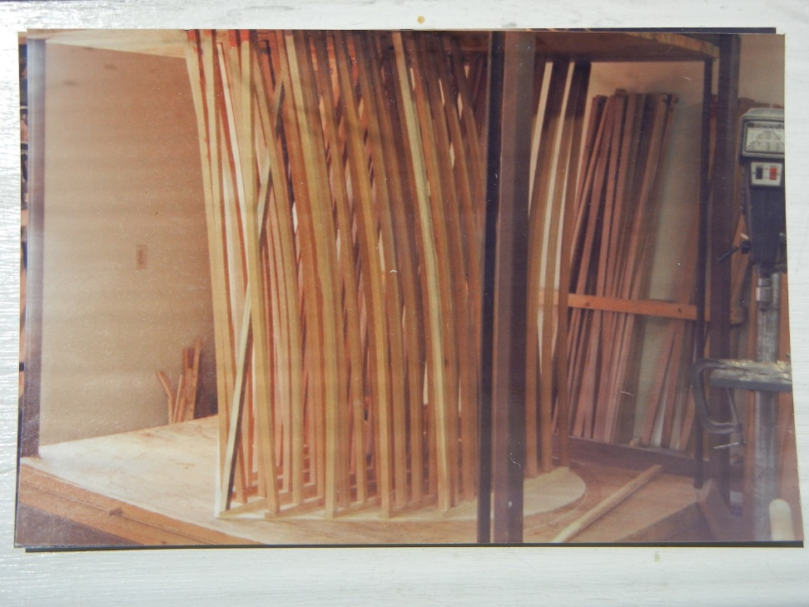

Gluing on the ribs.

