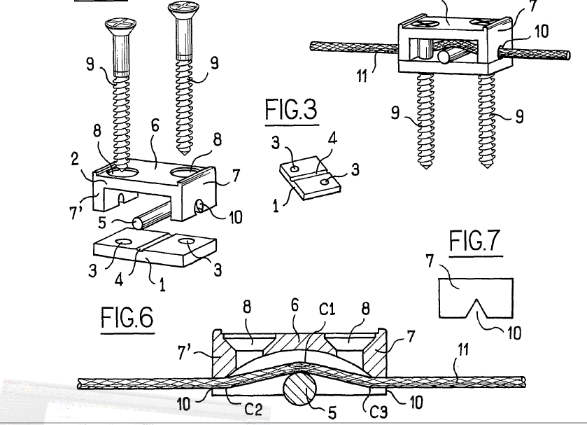
Oops, didn’t go in the note.

