On agraffes that were not threaded up to the head, the hole in the plate was relieved so there were no threads there. (This was not done on all pianos with agraffes not threaded to the head.)
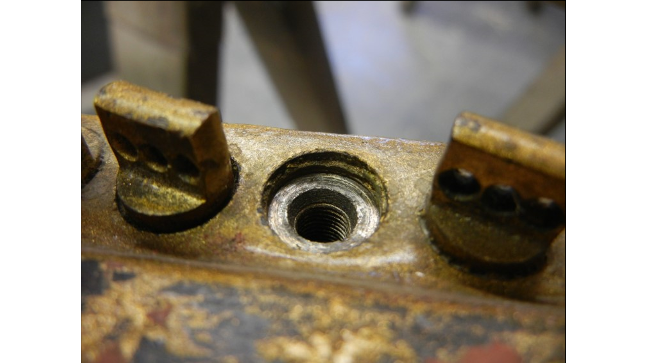
The main cause of breaking was that they were overturned when installed, which can be seen if you look at the base of the agraffe head, it will be mushroomed out.
I took new agraffes and turned them till they broke, then inspected them and compared them to old agraffes.

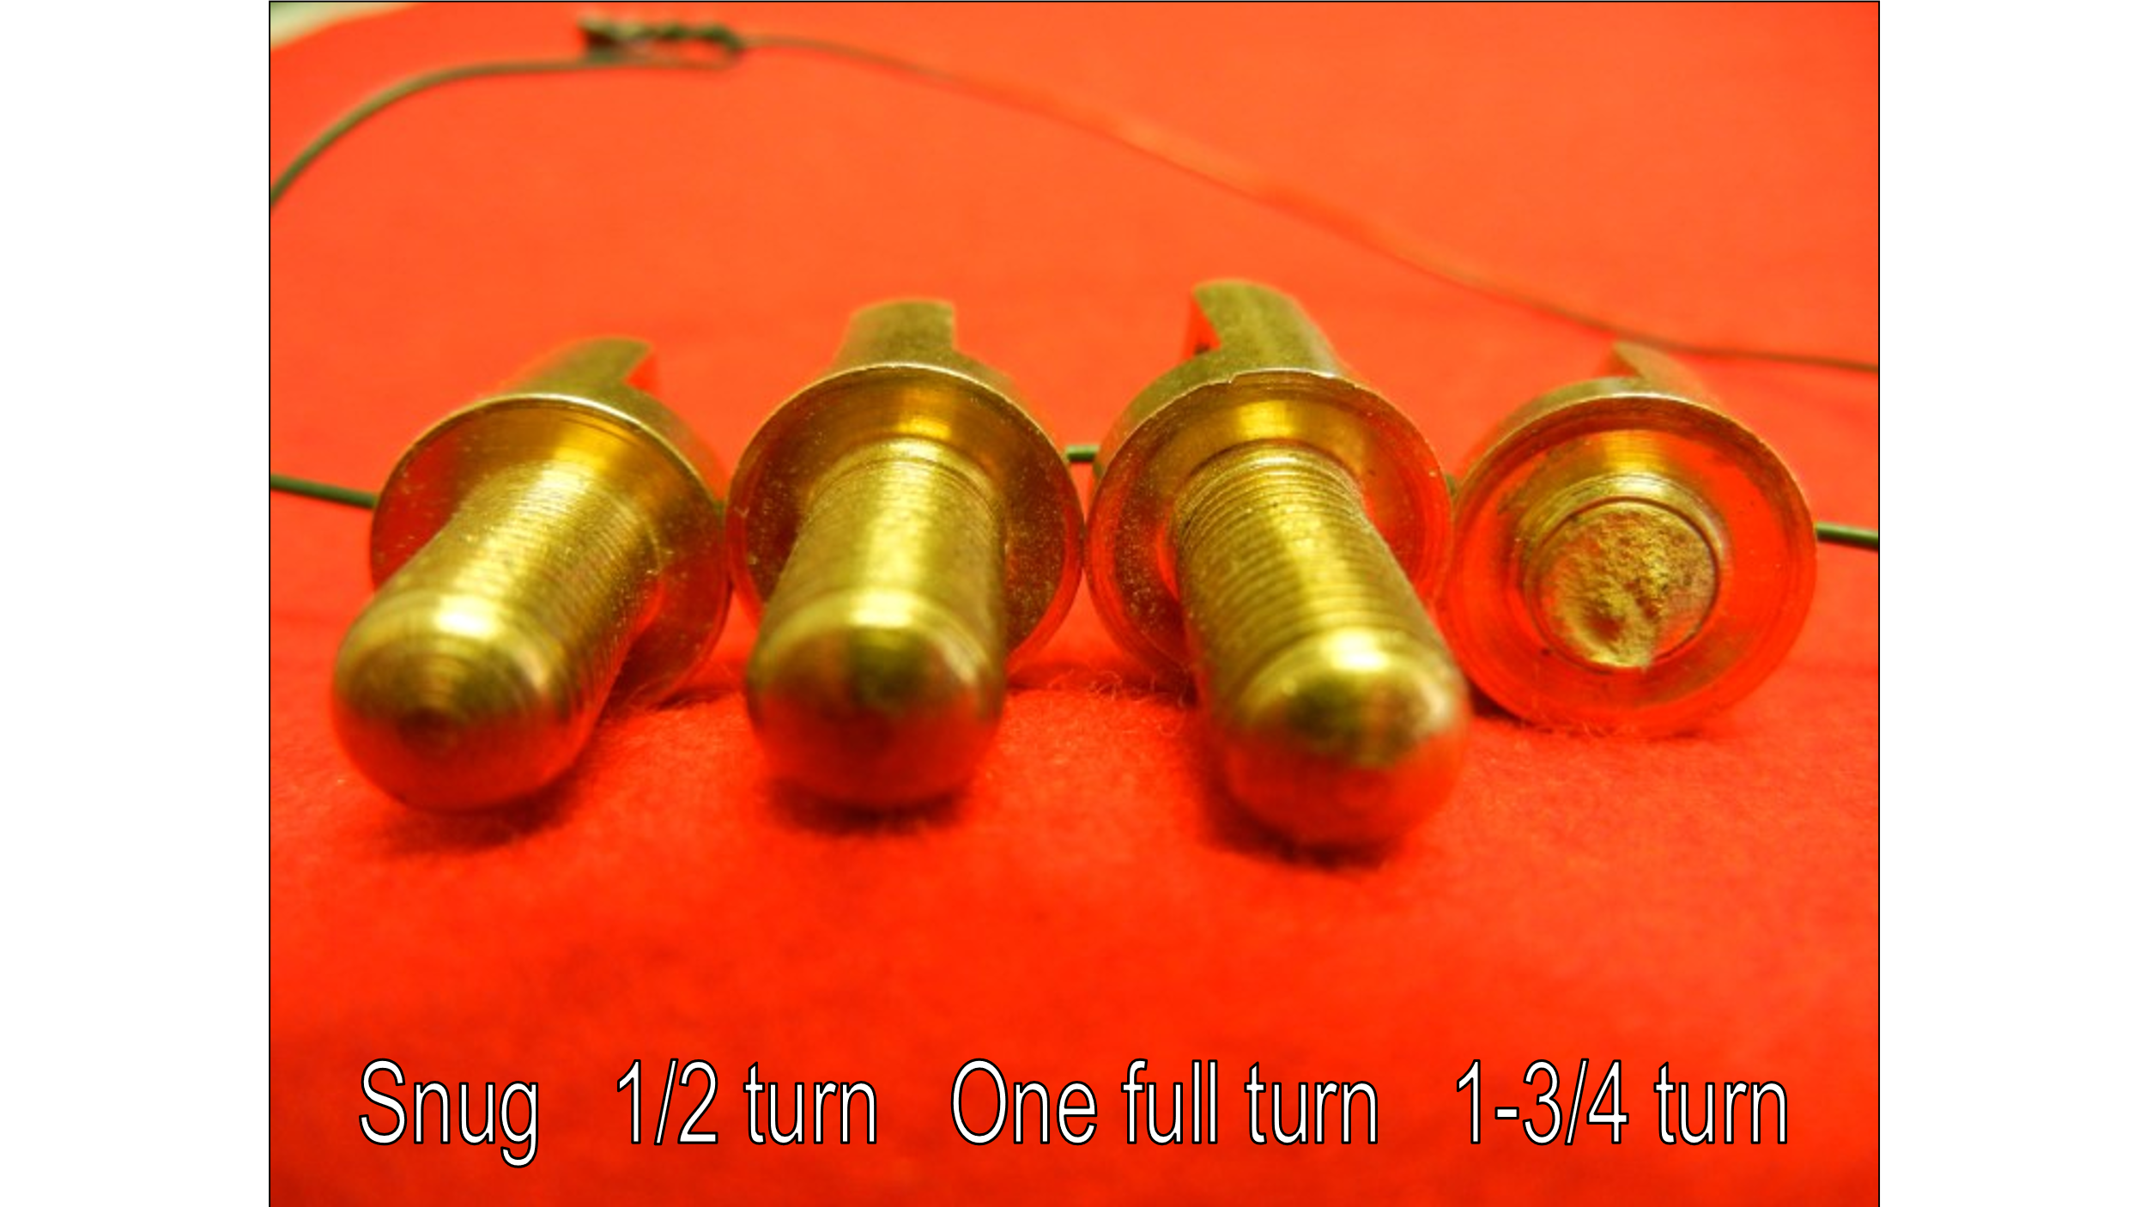
Looking at the base of the head you can see how it flattened out.
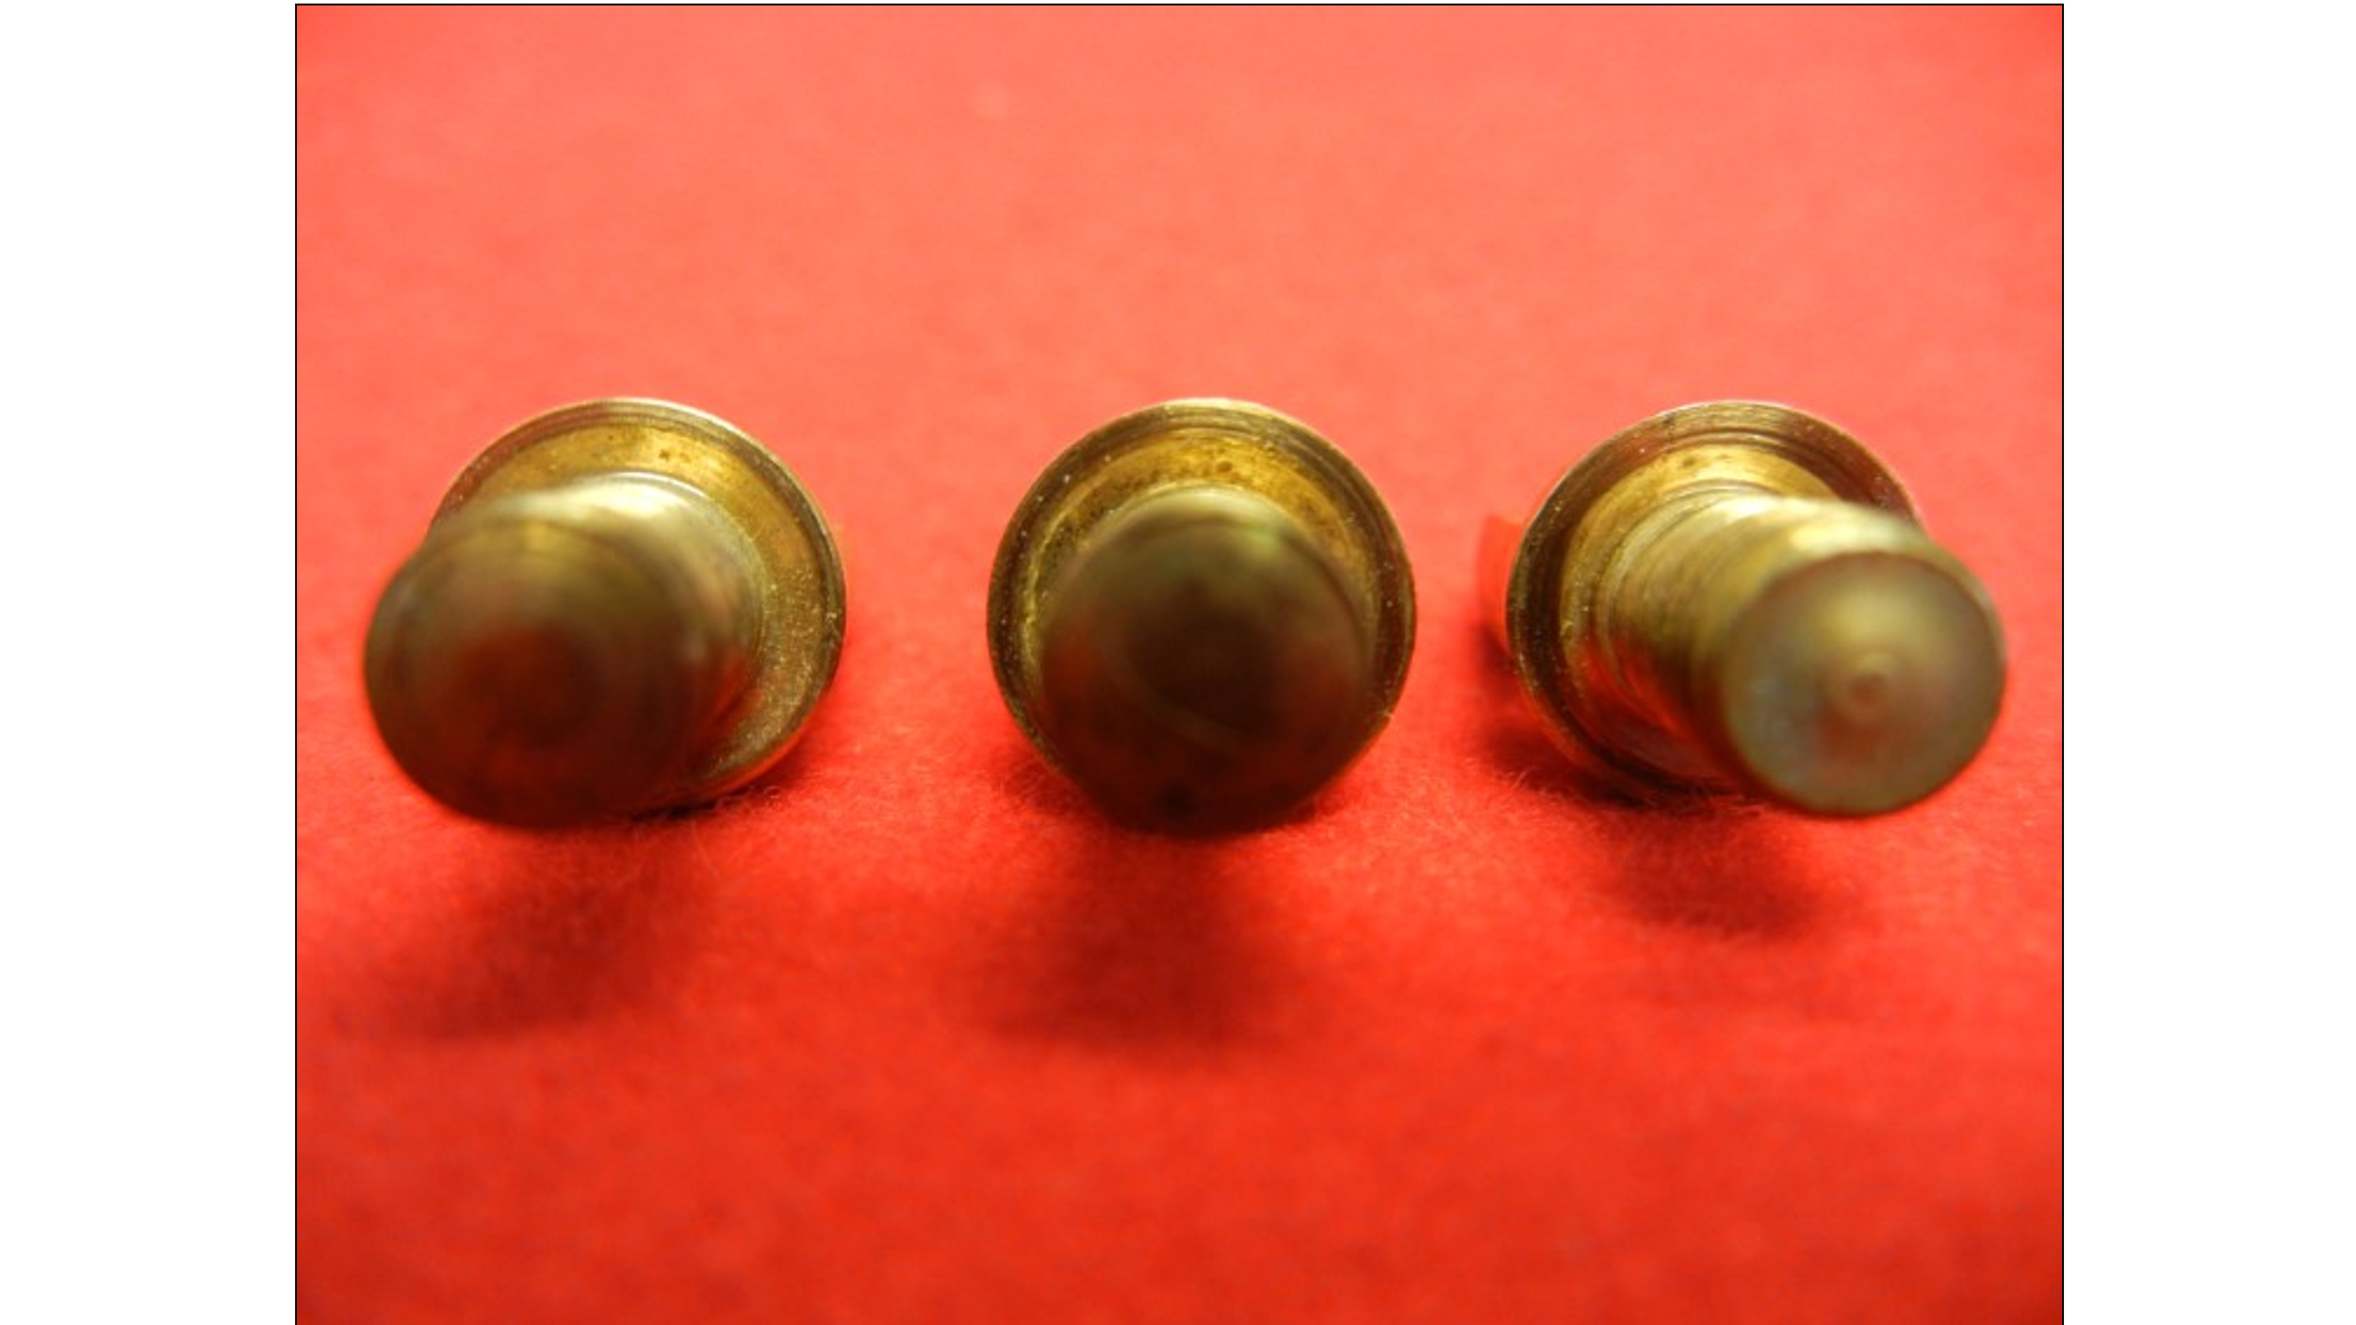
These are old agraffes turned in to different degrees of torque. Compare with the ones that I turned till they broke.

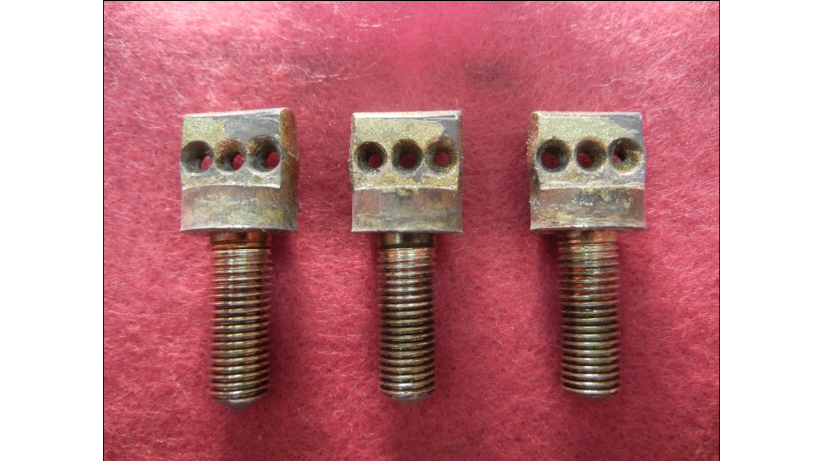
You can how much the base of the head has mushroomed out from overturning.

Now on newer Steinways in and around serial number 400000 they break because of a stress concentration. They actually shatter.

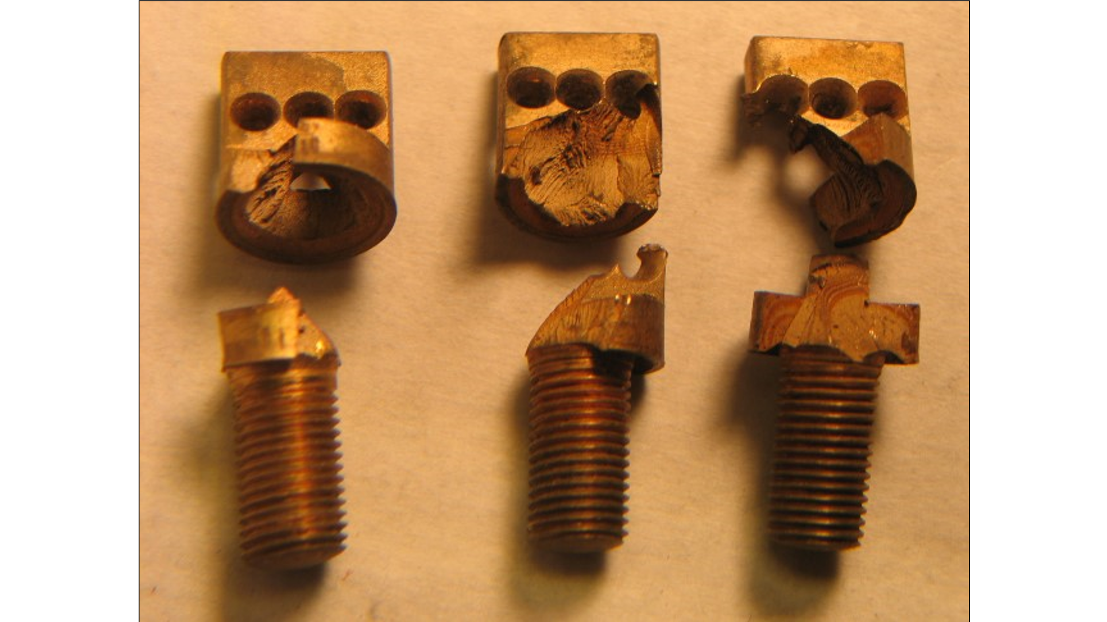
These are from different pianos.

