Features
Kills Norovirus in just 4 Minutes
EPA Registered Broad-Spectrum Disinfectant
Kills 99.9% of Bacteria, Viruses*, Fungi & Molds
Bactericidal, Virucidal*, Tuberculocidal, and Fungicidal**
Disinfect, Sanitize, Clean, and Deodorize in ONE STEP
Kills, Destroys and Eliminates Household Germs
No Rinse Required, even on food contact surfaces
Sanitizes Soft Surfaces in just 2 minutes
Eliminates 99.9% of most Allergens§ upon contact
Formulated for use with Mechanical, manual, or battery/power operated sprayers
Kills Odor Causing Bacteria
Kills bacteria that can cause food poisoning
One-step Hospital Disinfectant Cleaner
Non-Abrasive and Non-Corrosive
Non-Flammable – No Harmful Chemicals
Cleans and Disinfects without Bleaching
Free from Chlorine and Phosphates
No Signal Words or Warnings Needed
No Personal Protective Equipment (PPE) Needed
Heavy Duty Cleaner and Disinfectant
Ready-to-Use Formula
Safe for Everyday Use
Pleasant Lemongrass Grapefruit Scent
Effectively Controls Unpleasant Strong Odors
Botanically Derived Active Ingredient
Formulated with Patented Technology
Effective in Restoration and Remediation
Safe for Use on Water Mitigation (Sewage Back Up, Water Damage)
Formulated without phthalates, propylparaben, butylparaben, formaldehyde, formaldehyde-dnors, or NPE’s
*Virucidal according to the ASTM Standard Test Method for Efficacy of Virucidal Agents
** Fungicidal according to the AOAC Germicidal Spray Method
§ Removes the following allergens: dust mite matter, cat dander, dog dander, mouse dander, rat dander, guinea pig dander, cockroach matter, peanut, birch pollen, timothy grass pollen, rag weed pollen.

Germs, bacteria, viruses and other malevolent micro-organisms may be small in size, but the threat that they pose to human health is striking. When cleanliness really counts, professionals reach for Bioesque’s Botanical Disinfectant Solution.

Disinfecting Done Right
Capable of cleaning, sanitizing, disinfecting and deodorizing in a single step, Bioesque’s Botanical Disinfectant Solution is the natural solution for a wide range of cleaning challenges. This innovative product: Features the patented Thymox technology and a botanically derived active ingredient.
- Is a one-step cleaner with bactericidal, virucidal, tuberculocidal and fungicidal claims.
- Is a broad-spectrum disinfectant registered with the Environmental Protection Agency.
- Cleans, disinfects, and deodorizes a wide array of surfaces.
- Eliminates malodors and features a fresh lemongrass-grapefruit scent.
- Is nonabrasive, environmentally friendly and ideal for everyday use,
- Contains no chlorine, phosphates or harsh chemicals.
- Does not require the use of personal protective equipment.
- Is effective in restoration and remediation situations.

Strength, Speed, and Sensitivity
With a formula that is free of bleach and other harsh chemicals, Bioesque’s Botanical Disinfectant Solution is a great choice for hazard-conscious or environmentally sensitive settings. Powered by Thymox technology, it utilizes Thymol, a cutting-edge antimicrobial agent present as a component of Thyme Oil, to quickly power through grime and destroys the germs that it encounters. How efficiently does this professional-grade product work? This disinfectant:
- Kills 99.99 percent of viruses in one minute.
- Kills 99.99 percent of bacteria in two minutes.
- Kills 99.99 percent of fungi and molds in three minutes.
- Kills Mycobacterium tuberculosis in three minutes.
Available in multiple sizes, Bioesque’s Botanical Disinfectant Solution is an undeniably useful tool for restoration and cleaning professionals. It is perfect for use on an impressive array of surfaces and requires no special precautions or equipment to use. After spraying, simply allow the product to sit on the surface for the appropriate period of time before wiping it down, if desired. This versatile product is suitable for health care, residential, commercial and industrial settings and ideal for restoration scenarios.

Product Efficacy
Sanitizing > 99.999% 30 Seconds: – Staphylococcus aureus – Enterobacter aerogenes
Kills 99.99% of viruses in 1 minute: – Swine Influenza A (H1N1) – HIV-1 AIDS Virus – Human Coronavirus – Respiratory Syncytial Virus (RSV)
Kills 99.99% of Fungi and Molds in 3 Minutes: – Trichophyton mentagrophytes (Athlete’s Foot Fungus) – Candida albicans
Kills 99.99% of bacteria in 2 minutes: – Staphylococcus aureus (Staph) – Salmonella enterica (Salmonella) – Pseudomonas aeruginosa (Pseudomonas) – Listeria monocytogenes (Listeria) – Escherichia coli (E. coli) – Escherichia coli (E. coli O157:H7) – Streptococcus suis (Streptococcus) – Vancomycin-Resistant Enterococcus (VRE) – Methicillin-Resistant Staphylococcus aureus (MRSA) – Klebsiella pneumoniae
3 minutes: – Mycobacterium Bovis BCG (TB; Tuberculosis)
Respiratory illnesses attributable to Severe Acute Respiratory Syndrome (“SARS”) are caused by a Coronavirus. Bioesque® Botanical Disinfectant Spray is a broad-spectrum hard surface disinfectant that has been shown to be effective against other similar viruses.
Recommended For Use In:

Crawl Spaces
Attics
Basements
Public Buildings
Common Areas
Automotive
Public Transportation
Multi-Family Housing
Residential Housing
Commercial Real Estate
Hotels and Motels
Institutional Facilities
Correctional Facilities
Military Installations
Offices
Athletic Facilities
Retail Stores
Churches
Colleges
Kitchens
Veterinary Premises
Barber Shops
Farms
Airports
Cruise Ships
Schools
Day Care Centers
Nurseries
Hospitals
Aging Care Facilities
Nursing Homes
Ambulances
Surgery Centers
Health Care Facilities
Clinics
Medical and Dental Offices
Restaurants
Cafeterias
Institutional Kitchens
Food Processing Plants
Dormitories
Classrooms
Bathrooms
Public Restrooms
Tanning Salons

Suitable For Use On:
Countertops
Stovetops
Refrigerator Exteriors
Trash Cans
Floors
Appliance Exteriors
Telephones
Door handles
Hard, Non-Porous Surfaces of Sinks
Toilet Seats
Bathtubs
Shower/Bath Areas
Vanities
Walls
Windows
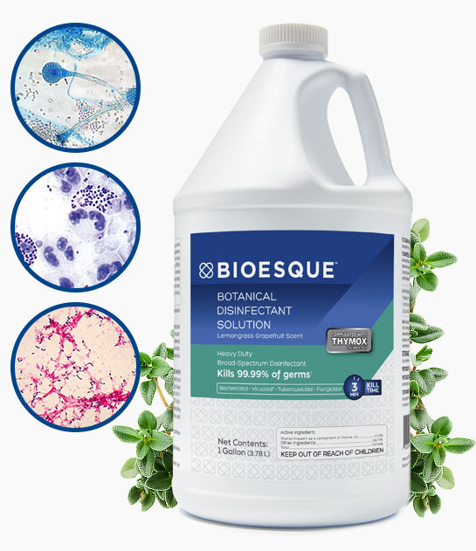
Mirrors
Hard Sporting Equipment
Cups/Helmets
Examination Tables
Patient Chairs
Tables
Doors
Baby Furniture
Changing Tables
Cribs
Highchairs
Metal
Glazed Ceramic
Glazed Porcelain
Glazed Enameled Surfaces
Glass
Sealed Marble
Steel
Stainless Steel
Brass
Aluminum
Sealed Concrete
Plastic
Polypropylene
Polystyrene
Polyethylene
PVC
Glazed Tile
Sealed Fiberglass

