## **Southeast Seminars**

**Last chance for 2020**

## Thursday, November 12th - 7:30 pm Eastern Time

**Websites for Technicians - Presented by LocalMarketPlace YourLMP.com**

[Register Here](https://us02web.zoom.us/meeting/register/tZ0qcOusqz8sGdbNYUs1Y0zWr0hU7PU3V3PR)

"In this session, we will cover "What makes up an Effective Website for Technicians." It will include Website design issues, appealing to your audience, reaching your target audience, and converting prospects into paying customers.

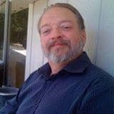**Wayne Ivey – President, Local MarketPlace**

Wayne has over 40 years of Marketing/Advertising and sales experience, including applying technology solutions to business problems. He has started or partnered in 5 successful businesses and helped many others.

**Local MarketPlace:**

We dedicate ourselves to helping our clients succeed by providing effective, affordable Digital Marketing Solutions. These include Online Reputation Marketing and Organic Traffic Solutions such as Video Marketing, GMB Optimizations, and Local Search Engine Optimization (SEO).

Our Mission is to help you achieve success in your business! We want to enhance your internet presence to gain more visibility, more traffic, more conversions, and more sales. We are committed to your success and will customize a solution that will bring you the most customers.

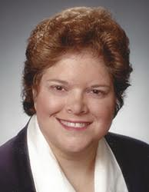**Margaret Savoy – Website Developer/ SEO Specialist**

 Margaret has been designing websites for local businesses for 15 years. This quickly evolved into providing search engine optimization for these businesses, as a website is only useful in marketing if people can find it. As part of the Local Marketplace team, she has led our tech department since 2008, staying on top of the ever-evolving digital marketing space and providing a myriad of digital marketing services to our local clients.

 Before her career in digital marketing, Margaret was a teacher and an engineer. She taught High School Physics and Algebra for two years in Louisiana after her career at NASA as an engineer, where she oversaw the operations team of the Electrical Power System for the space station. This grounding in process and procedures translated well to the Digital Marketing arena.

At Local MarketPlace, our Mission is to help you achieve success in your business! We want to enhance your internet presence to gain more visibility, more traffic, more conversions, and more sales. We are committed to your success and will customize a solution that will bring you the most customers.

**Our goals are to:**

* Increase traffic to your website
* Ensure websites are "Sales Machines."
* Help your business become more profitable
* Generate top search engine rankings for your business
* Provide you with outstanding service

You can turn visitors into customers with a website that drives sales. The website needs to do more than look nice. It has to drive your customer to take action. We ensure your website is mobile-friendly, loads fast, is ready to rank, and is designed for customers to take action. With the right website, you can blow away your competition.

## Thursday, November 19th - 7:30 pm Eastern Time

**Dampp-Chaser Piano Life Saver Systems -**  **Installing the Piano Life Saver System**

[**Register Here**](https://us02web.zoom.us/meeting/register/tZwrd-2hrz8tHNVhocIkrUqdgjiEdHNBjtXR)

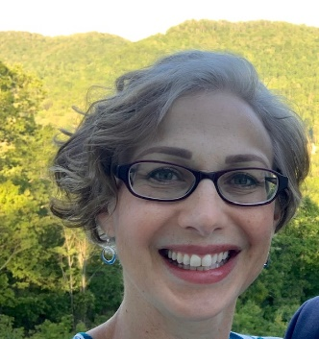

**Kelly Hollifield**

There's a right way and a wrong way to do any task.  Installing a Piano Life-Saver System requires adhering to the RIGHT way for the system to work properly and the customer to be happy.  Learn why and how in this informative presentation. We will explore and explain the many different configurations of grand pianos and uprights.

## **Coming in January and February 2021**

**USE YOUR TOOLS**

**A seminar series exploring ways Aural and ETD methods can improve your skills as a Piano Technician.**

I am still seeking seminar instructors for this series. Send your seminar outline to [SERVP@ptg.org](mailto:SERVP@ptg.org) or call me 770.778.6881.

**Join us!** As SERVP, my focus**, "promoting quality service for the world's pianos,"** is to provide **all** technicians the means to learn, achieve, and provide quality service. No one ever knows everything about our profession, yet together we have amazing expertise.  We all benefit when we discover better ways of accomplishing tasks of the trade. This discovery is the purpose of Southeast Seminars. All technicians will benefit from this presentation and should plan to participate. It is my privilege to host Southeast Seminars, bringing these educational opportunities to you, a core function of PTG.

Come and **share your expertise**.  Please help us expand knowledge, improve skills, and share experience! Find a day, any day that works for you, and schedule a ZOOM technical presentation. Don't let this COVID bug win!  I KNOW there are other folks with the means and where-with-all to put on a Zoom class.  Education is the key to advancement.  It is also the key to self-improvement, and continuous improvement is a foundational element of PTG.

Southeast Seminars is for all of us.

LET'S DO THIS!!!

Contact Bill Davis, SERVP  [HERE](mailto:bill@thepianoplace4.us?subject=Summer%20Seminar%20Series), and schedule a ZOOM Seminar.